CLARINS COSMETICS DOCUMENTATION

Table of Content:

* E-project Report.
* Acknowledgement.
* Project Analysis.
* Synopsis of Project.
* Users Guide.
* Developers Guide.
* Flow chat.
* Data flow diagram.
* Database process.
* Screenshots.

E-PROJECT REPORT

**Project name**: Clarins Cosmetics.

**Project start date**: 22nd April 2023.

**Project end date**: 13th May 2023.

**Semester**: 1.

THIS IS TO CERTIFY THAT THE FOLLOWING STUDENTS:

* Kachisikwuo Chimeremeze Ibekwe [Student1418147].
* Ibukwuoluwa Thomas [Student1426912].
* Chinonso Magnus Ugwuezumba [Student1422282].
* John Emeka Awa [Student14525353].

Have successfully created a single page web application with HTML, CSS,

JavaScript, Bootstrap and AngularJS for a French based cosmetics brand named Clarins.

ACKNOWLEDGEMENT

We would like to show our sincere appreciation to the following people, because without them this project wouldn’t have been success:

* Mr. Chibuzor Christian Ihueze (Faculty Teacher).
* Mr. Adebowale Mabadeje (AngularJS. Teacher).
* Mr. Cyril Odogwu (Project Supervisor).
* Kachisikwuo Chimeremeze Ibekwe [Student1418147] (Group member).
* Ibukunoluwa Thomas [Student1426912] (Group member).
* Chinonso Magnus Ugwuezumba [Student1422282] (Group member).
* John Emeka Awa [Student14525353] (Group member).

We would like to express our gratitude and appreciation to all who gave us the opportunity to

Complete this project. We show our sincere appreciation to our teacher and faculty, Mr

Chibuzor Christian Ihueze whose help, stimulating suggestions and motivational speeches

Helped us in all time of building the web application.

We would also like to express our gratitude to the e-Projects Team at the Head Office, who

Guided us through by giving specifications and guidelines that helped us throughout the

Building process.

Many thanks to the staff members of our centre for not only providing us with the

Opportunity to work with them on this project, but also for their support and encouragement

Throughout the process. We also want to acknowledge the resources we used for program

References and libraries:

https://www.w3schools.com/

CLARINS COSMETICS DOCUMENTATION

**Project Analysis**:

We would be analysing all factors that can make the project to succeed in this project analysis. We are identifying Clarins cosmetics goal, which is to allow all customers to be able to purchase Clarins cosmetics products from the website irrespective of their location.

The core aim of designing this project for Clarins cosmetics is to make it easier for customers to get their required products from the comfort of their mobile devices, than coming to the stores for the products. This website will give Clarins cosmetics a larger audience and thereby expanding the scope of the business and having more customers.

The methods used in building this website is e-commerce website method for easy navigation by the users. In this website you can see our products, their descriptions and the prices of each of the products on the Clarins cosmetics website, with this website it is very easy to find the required project of your choice because the product section is very much visible. This website is quite easy to navigate by all users because it is simple and convenient.

Due to our research, we recommend that Clarins cosmetics should change the locations of where the categories, most popular and what’s new section should be placed a little be more at the top section of the website after the products slideshow section and the products catalog section in order for the website users to be able to navigate more easily into the brand’s products.

**Synopsis of the Project**:

Clarins is a French brand of skincare for the face and body. With a genuine passion to deliver real and natural beauty solutions, the brand started with a beauty spa and its own project line. With more than 60 years in the industry in the industry and close communication with consumers, Clarins is a reference in premium beauty – with a wide catalog that offers skincare solutions for the face and body, makeup and fragrances. There are some iconic products that stand from the catalog, such as the face oils, the unique Double Serum and also body treatments that represent the essence of the brand - every product conveys expertise and top performance of Clarins beauty solutions.

The project involves building a website for Clarins cosmetics. The website also comprises sections for Clarins cosmetics products, Gallery, About, Sitemap, Contact us, visitors count. This project helps users to view the product of Clarins cosmetics.

The project is an e-commerce project where a user can order for products such as body products, make up, and perfumes.

For the actualization of the project, we the members of the project, that is Clarins cosmetics are Kachisikwuo Chimeremeze Ibekwe, Ibukunoluwa Thomas, Chinonso Magnus Ugwuezumba, John Emeka Awa, we all worked together to make the project a successful one.

Kachisikwuo Chimeremeze Ibekwe was responsible for making sure everyone was being focused on the project and were comfortable with whatever tasks given to them, he was also responsible for the documentation if the project.

Ibukunoluwa Thomas was responsible for coding the top section of the website which consists of the logo, the gallery and the animations on the home page. The main work for Ibukunoluwa Thomas was for him to make sure everything is well structured and layout for easy navigation by the end users. Ibukunoluwa Thomas was also responsible for making the website to be responsive in all devices. Ibukunoluwa Thomas. He was in charge of the product section and he made sure that the products are appealing to the users. Ibukunoluwa Thomas did his part well and delivered on time. did his part well and successfully completed.

Chinonso Magnus Ugwuezumba was responsible for the navigation, fonts, icons that are were used in the project. Chinonso Magnus Ugwuezumba was also responsible for the popup images, he was responsible for all the images that were used in the website, he made sure the best quality image and saleable images are available for use throughout the project.

John Awa was responsible for the navbar, contact us page, about us page, and helped in most of the javascript codes he made sure that the contact page must provide detailed information about the website where a user can contact Clarins cosmetics.

I can say all the work shared among the group members were done properly and submitted before the deadline for the project. I can say we have a united group because group project can only succeed by working together.

The motive behind this project is to provide website for customers to shop easily for all their Clarins cosmetics products. The main reason was to reduce the time and effort a customer would spend coming to the shop to buy products, with this website the customer just needs to check for his/her preferred products online and place an order for it. One of the reasons for this website was to reduce stress, time and energy of customers coming to our store to purchase our products. This website provide solution to all our customers because Clarins cosmetics has spread throughout the world and there is need for us to make our products more accessible for the buyers to purchase products, hence Clarins cosmetics website.

The resources we used for the successful completion of the project, we used Aptech Computer Education e-books, this book was very helpful as all the technologies and useful instructions used were all inside the e-book. We also used the internet to upload all the images used and sort for proper explanation of some difficult areas for proper understanding of the concept that is not clear. We also used the internet for all the links used such as JQuery library link, bootstrap link, Google font link, Angularjs cdn link.

The technologies used for the completion of the project were Html, XML, JQuary, bootstrap, JSON, CSS, and AngularJS. Html was very easy to use and there was no issues with the technology at any given point in time. CSS was also easy to use at all time. Bootstrap was also easy to use and it made the work faster. XML was very simple to use also as it gave extensible mark-up of the code.

**Users Guide**:

In this users guide we are going to teach the end users of this website of how to use the site for their solution rather than creating more problems. This guide will help you to navigate easily throughout the website.

HOW TO USE THE MENU OPTIONS

When you open Clarins cosmetics website you will see Home, Gallery, Product, About us, Site map, Contact us with visitors count and the Clarins logo on the top header of the website if you are using a desktop or laptop to view the website.

On the other hand if you are using mobile devices you will see a hamburger menu icon which when clicked will display Home, Gallery, Products, About us and Contact us. A hamburger menu is just like three lines joined together with space in between them, it is found on the right top side of the website.

On clicking on any of them will take you to the section of the website, for example clicking on the product will take you to the product section where you can select your product with ease. Clicking on contact also will take you to the contact section where you can contact Clarins cosmetics hotline.

Clicking on the gallery you will see all the pictures of Clarins cosmetics products, you will see pictures of perfumes, creams, body washes etc. on clicking on any of them like say perfumes, all images of perfumes by Clarins cosmetics will be displayed with their description and prices.

On clicking on the home section everything concerning the home section comes out. On clicking of the about us everything concerning the cosmetic brands history would appear.

HOW TO BUY/PLACE ORDER FOR A PRODUCT

If you want to buy any of the Clarins cosmetics product, for example you want buy a perfume all you have to do is just click on the product section on the menu, all the products will be displayed. Click on perfume and you will see all images of perfumes will come up with their description and prices, select your preferred choice.

After selecting your product from the product section you \*\*\*.

HOW TO CONTACT US

Locate the contact us link, then choose the preferable means of communication either by email, contact number of Clarins cosmetics or visit to our office or store which the address is placed there on the website.

**Developers Guide**:

In this developers guide, we use different modules which means that the website which is Clarins cosmetics websites were divided into modules.

We have the modules that made the menu to be possible. We have the home modules that make sure everything concerning the home page is achieved, in the home modules which are independent codes work together to form the home page of the said website.

In this website we have contact modules which work together to make sure the contact page is fully responsive, it is these modules that are responsible for the user of the website to make contact to order for their products.

We also have the carousel modules, these modules are responsible for the images to be sliding automatically to view different images.

We have the header modules, these are the modules that make sure all the navigational links are fully working. All the modules for the header are linked together to have a functional header section.

We have the gallery modules, these are the modules that are responsible for making sure that the gallery images are fully viewed by the users.

We also have modules that are responsible for the pop up images. These are responsible for all the codes that are written concerning the popup images are fully functioning.

We also have the modules that are responsible for the description of items and there prices.

We have the modules that are responsible for making the about us page to function. These modules are responsible of making sure that our about us are working according to the specification of the website.

We also have the modules that are responsible for making the geolocation of the website to work, these are the modules concerning the date, time and location.

We have the modules that are responsible for the working of the site map, these modules are working together so that a user of the website can locate our office through Google map.

We have the modules also that are responsible for the @mediaquery section to function .These are the modules that make sure that the website is viewed in all devices with the same quality. These modules are responsible for the overall responsiveness of the website.

We also have modules that are responsible for the animations of the website, these modules work together to make sure we have a good animation for the website.

we also have the modules that are responsible for the visitors count these modules work together to make sure anytime someone visits the said website the website counts the number of visitors.

In these modules we have the:

* HTML: The Hypertext Mark-up Language or HTML is the standard mark-up language for documents designed to be displayed in a web browser. It can be assisted by technologies such as Cascading Style Sheets (CSS) and scripting languages such as JavaScript. Web browsers receive HTML documents from a web server or from local storage and render the documents into multimedia web pages. HTML describes the structure of a web page semantically and originally included cues for the appearance of the document. HTML elements are the building blocks of HTML pages. With HTML constructs, images and other objects such as interactive forms may be embedded into the rendered page. HTML provides a means to create structured documents by denoting structural semantics for text such as headings, paragraphs, lists, links, quotes and other items. HTML elements are delineated by tags, written using angle brackets. Tags such as <img /> and <input /> directly introduce content into the page. Other tags such as <p> surround and provide information about document text and may include other tags as sub-elements. Browsers do not display the HTML tags but use them to interpret the content of the page.
* CSS: Cascading Style Sheets (CSS) is a style sheet language used for describing the presentation of a document written in a mark-up language such as HTML or XML (including XML dialects such as SVG, MathML or XHTML). CSS is a cornerstone technology of the World Wide Web, alongside HTML and JavaScript. CSS is designed to enable the separation of presentation and content, including layout, colours, and fonts. This separation can improve content accessibility; provide more flexibility and control in the specification of presentation characteristics; enable multiple web pages to share formatting by specifying the relevant CSS in a separate .CSS file, which reduces complexity and repetition in the structural content; and enable the .CSS file to be cached to improve the page load speed between the pages that share the file and its formatting. Separation of formatting and content also makes it feasible to present the same mark-up page in different styles for different rendering methods, such as on-screen, in print, by voice (via speech-based browser or screen reader), and on Braille-based tactile devices. CSS also has rules for alternate formatting if the content is accessed on a mobile device. The name cascading comes from the specified priority scheme to determine which style rule applies if more than one rule matches a particular element. This cascading priority scheme is predictable. The CSS specifications are maintained by the World Wide Web Consortium (W3C). Internet media type (MIME type) text/CSS is registered for use with CSS by RFC 2318 (March 1998). The W3C operates a free CSS validation service for CSS documents. In addition to HTML, other mark-up languages support the use of CSS including XHTML, plain XML, SVG, and XUL.
* JavaScript: often abbreviated as JS, is a programming language that is one of the core technologies of the World Wide Web, alongside HTML and CSS. As of 2022, 98% of websites use JavaScript on the client side for web page behaviour, often incorporating third-party libraries. All major web browsers have a dedicated JavaScript engine to execute the code on users' devices. JavaScript is a high-level, often just-in-time compiled language that conforms to the ECMAScript standard. [10] It has dynamic typing, prototype-based object-orientation, and first-class functions. It is multi-paradigm, supporting event-driven, functional, and imperative programming styles. It has application programming interfaces (APIs) for working with text, dates, regular expressions, standard data structures, and the Document Object Model (DOM). The ECMAScript standard does not include any input/output (I/O), such as networking, storage, or graphics facilities. In practice, the web browser or other runtime system provides JavaScript APIs for I/O. JavaScript engines were originally used only in web browsers, but are now core components of some servers and a variety of applications. The most popular runtime system for this usage is Node.js. Although Java and JavaScript are similar in name, syntax, and respective standard libraries, the two languages are distinct and differ greatly in design.
* AngularJS: AngularJS is a discontinued [free and open-source](https://en.wikipedia.org/wiki/Free_and_open-source_software" \o "Free and open-source software) [JavaScript](https://en.wikipedia.org/wiki/JavaScript" \o "JavaScript)-based [web framework](https://en.wikipedia.org/wiki/Web_framework" \o "Web framework) for developing [single-page applications](https://en.wikipedia.org/wiki/Single-page_application" \o "Single-page application). The AngularJS framework worked by first reading the [HyperText Markup Language](https://en.wikipedia.org/wiki/HTML" \o "HTML) (HTML) page, which had additional custom [HTML attributes](https://en.wikipedia.org/wiki/HTML_attribute" \o "HTML attribute) embedded into it. Angular interpreted those attributes as [directives](https://en.wikipedia.org/wiki/Directive_(programming)" \o "Directive (programming)) to bind input or output parts of the page to a model that is represented by standard JavaScript [variables](https://en.wikipedia.org/wiki/Variable_(computer_science)" \o "Variable (computer science)). The values of those JavaScript variables could be manually set within the code or retrieved from static or dynamic [JSON](https://en.wikipedia.org/wiki/JSON" \o "JSON) resources. AngularJS's design goals included:

1. to decouple DOM manipulation from application logic. The difficulty of this is dramatically affected by the way the code is structured.
2. to decouple the client side of an application from the server-side. This allows development work to progress in parallel and allows for reuse of both sides.
3. to provide structure for the journey of building an application: from designing the UI, through writing the business logic, to testing.

AngularJS implemented the MVC pattern to separate presentation, data, and logic components.[[8]](https://en.wikipedia.org/wiki/AngularJS" \l "cite_note-8) Using [dependency injection](https://en.wikipedia.org/wiki/Dependency_injection" \o "Dependency injection), Angular brought traditionally [server- side](https://en.wikipedia.org/wiki/Server-side" \o "Server-side) services, such as view-dependent controllers, to client-side web applications. Consequently, much of the burden on the server could be reduced.

* JQuery: Query is a JavaScript library designed to simplify HTML DOM tree traversal and manipulation, as well as event handling, CSS animation, and Ajax. It is free, open-source software using the permissive MIT License. As of Aug 2022, jQuery is used by 77% of the 10 million most popular websites. Web analysis indicates that it is the most widely deployed JavaScript library by a large margin, having at least 3 to 4 times more usage than any other JavaScript library. JQuery's syntax is designed to make it easier to navigate a document, select DOM elements, create animations, handle events, and develop Ajax applications. JQuery also provides capabilities for developers to create plug-ins on top of the JavaScript library. This enables developers to create abstractions for low-level interaction and animation, advanced effects and high-level, theme-able widgets. The modular approach to the JQuery library allows the creation of powerful dynamic web pages and Web applications. The set of JQuery core features—DOM element selections, traversal, and manipulation—enabled by its selector engine (named "Sizzle" from v1.3), created a new "programming style", fusing algorithms and DOM data structures. This style influenced the architecture of other JavaScript frameworks like YUI v3 and Dojo, later stimulating the creation of the standard Selectors API. Microsoft and Nokia bundle jQuery on their platforms. Microsoft includes it with Visual Studio for use within Microsoft's ASP.NET AJAX and ASP.NET MVC frameworks while Nokia has integrated it into the Web Run-Time widget development platform.
* Bootstrap: Bootstrap is a free and open-source CSS framework directed at responsive, mobile-first front-end web development. It contains HTML, CSS and (optionally) JavaScript-based design templates for typography, forms, buttons, navigation, and other interface components.

It also includes the XML modules and JSON modules, All these modules are connected together to give a responsive and comprehensive website. In conclusion the website was divided into modules for easy coding and eventually connected together to give us Clarins cosmetics functional website.

FLOWCHART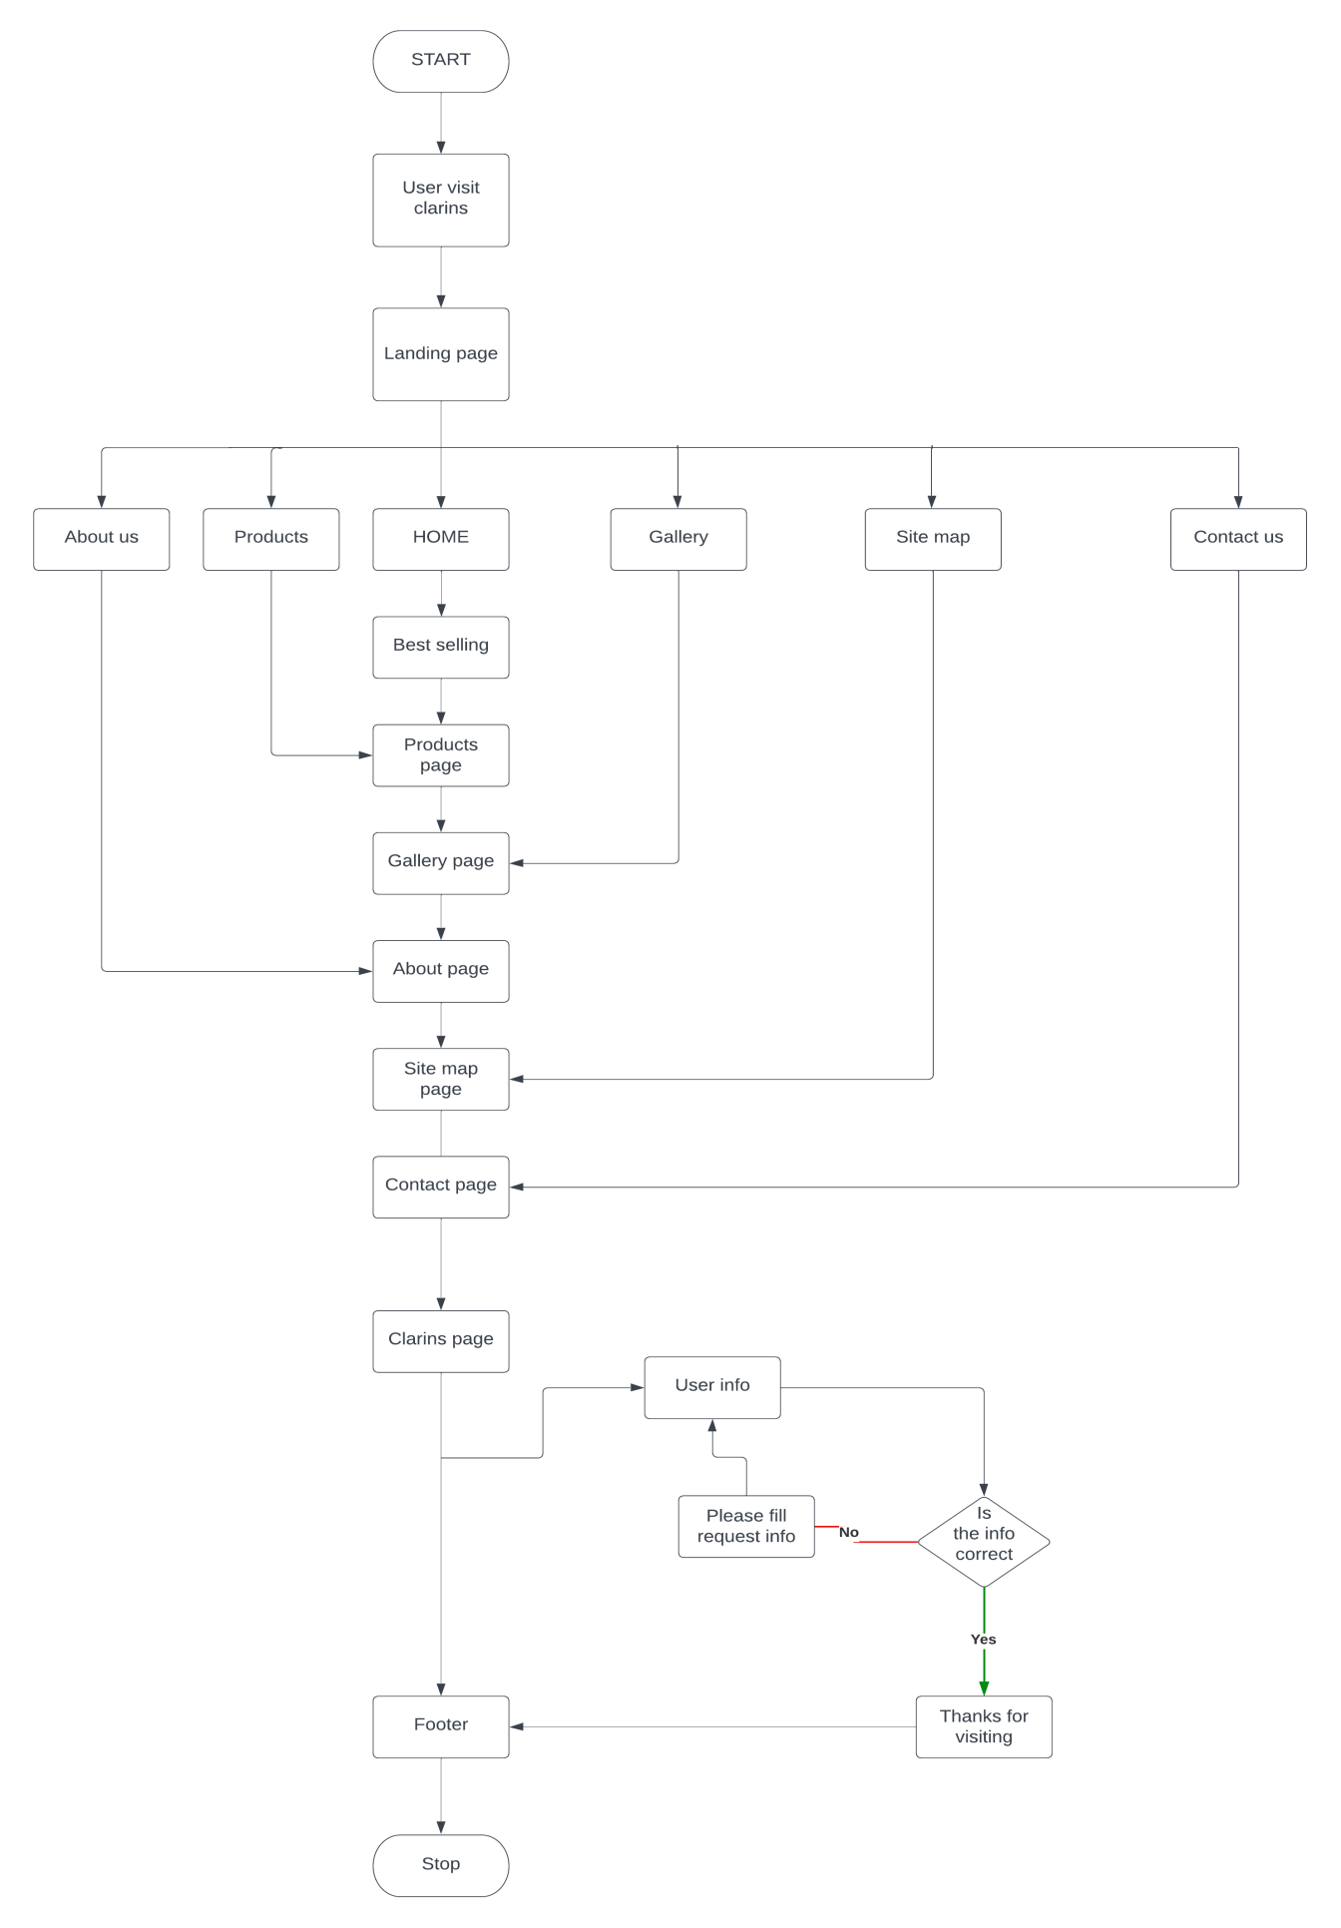

DATA FLOW DIAGRAM

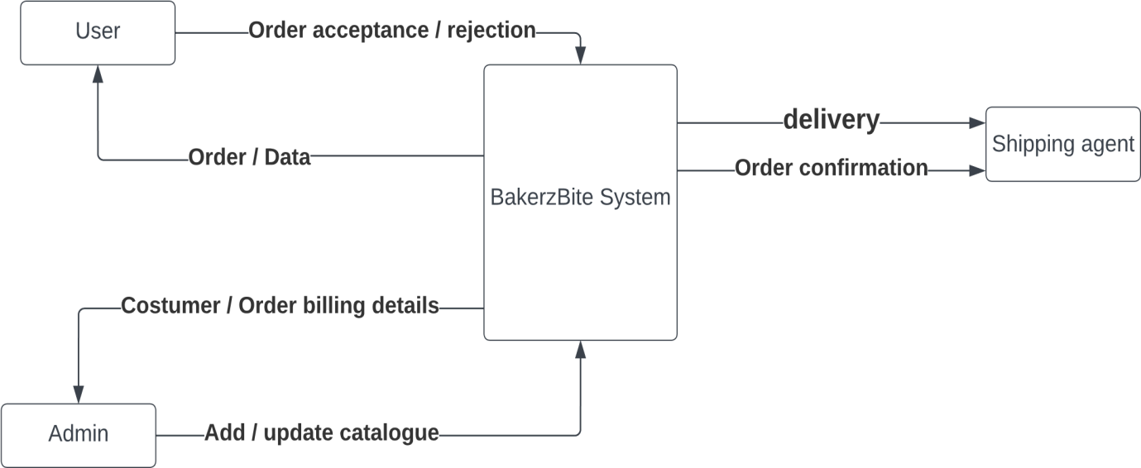

Clarins cosmtics System

DATABASE PROCESS

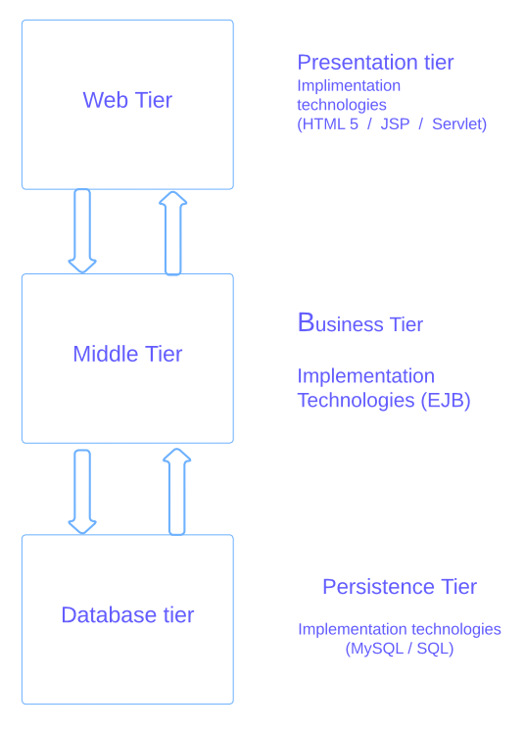

SCREENSHOTS OF CLARINS

NAVBAR



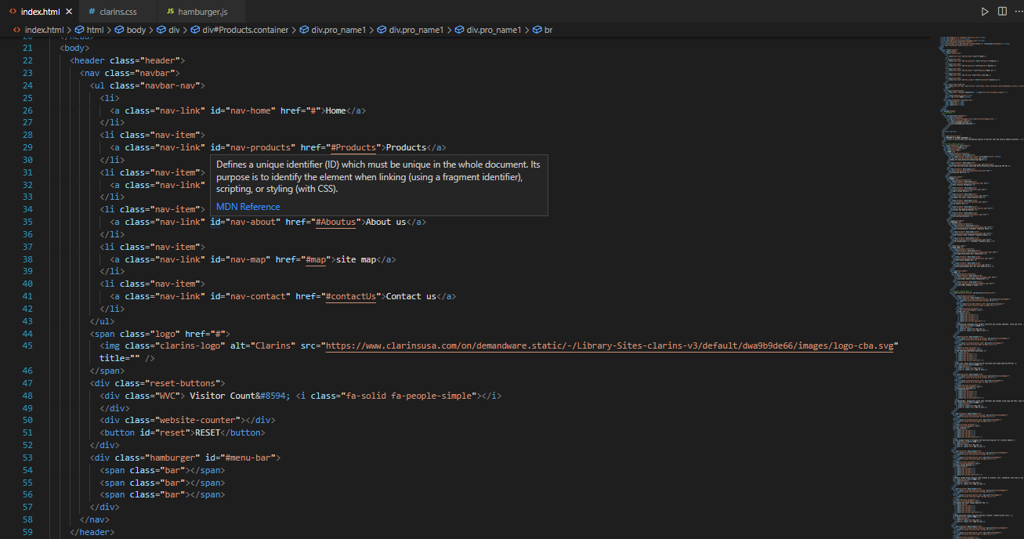

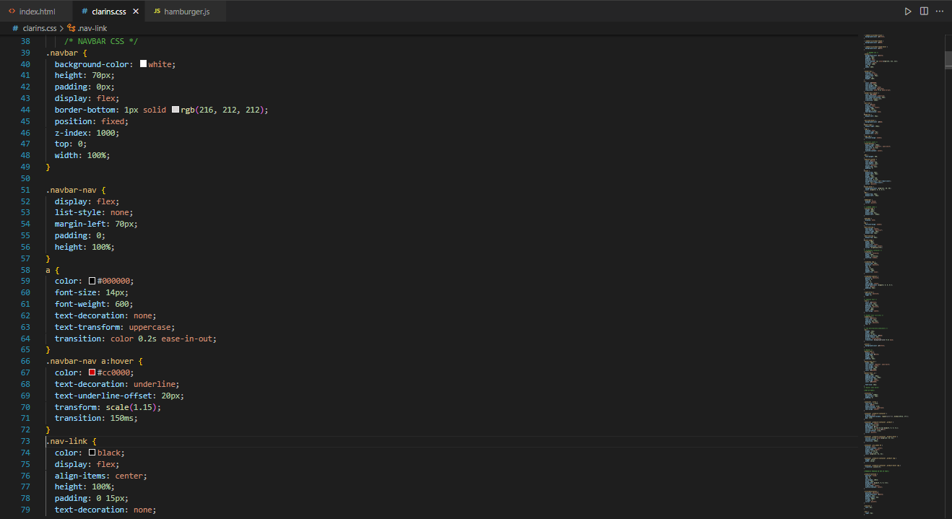

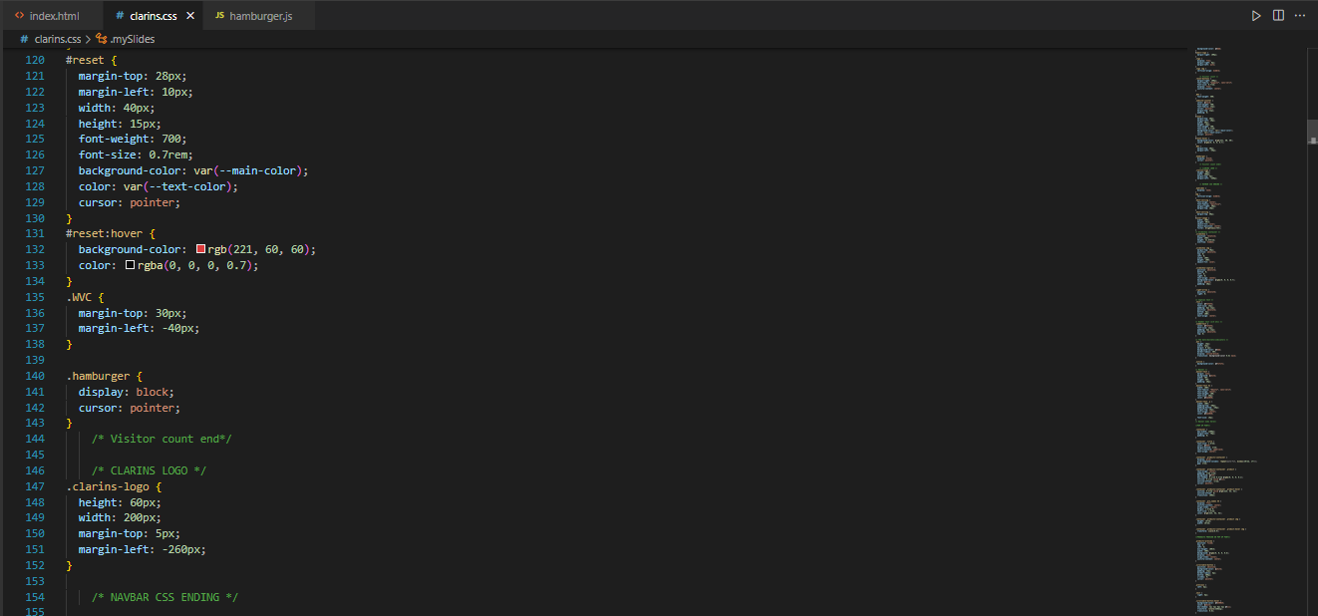

CAROUSEL/BEST SELLING PRODUCTS

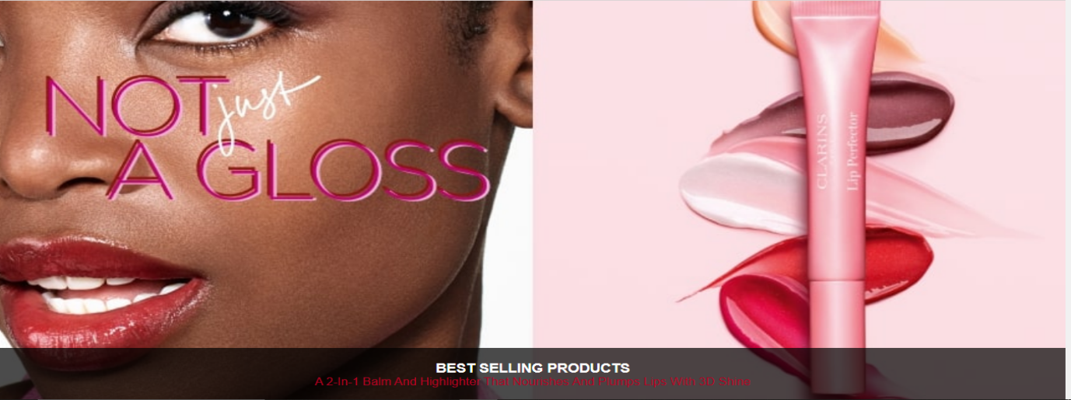

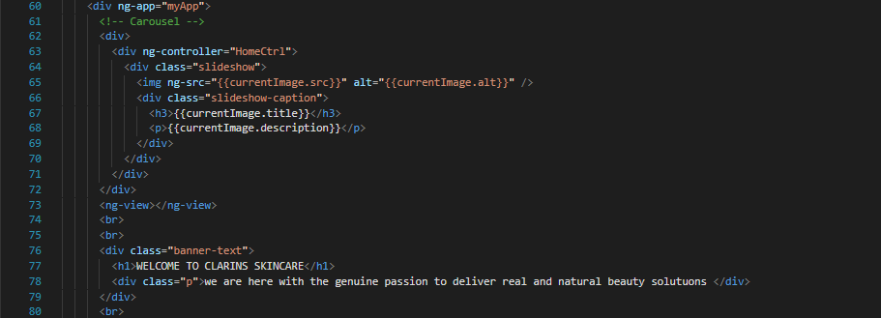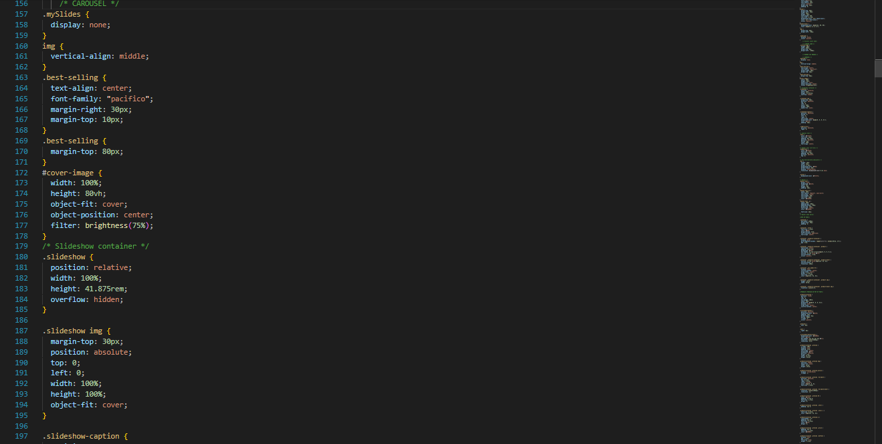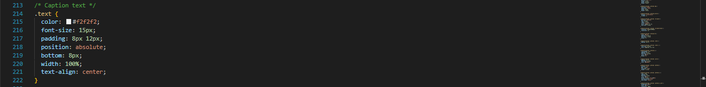

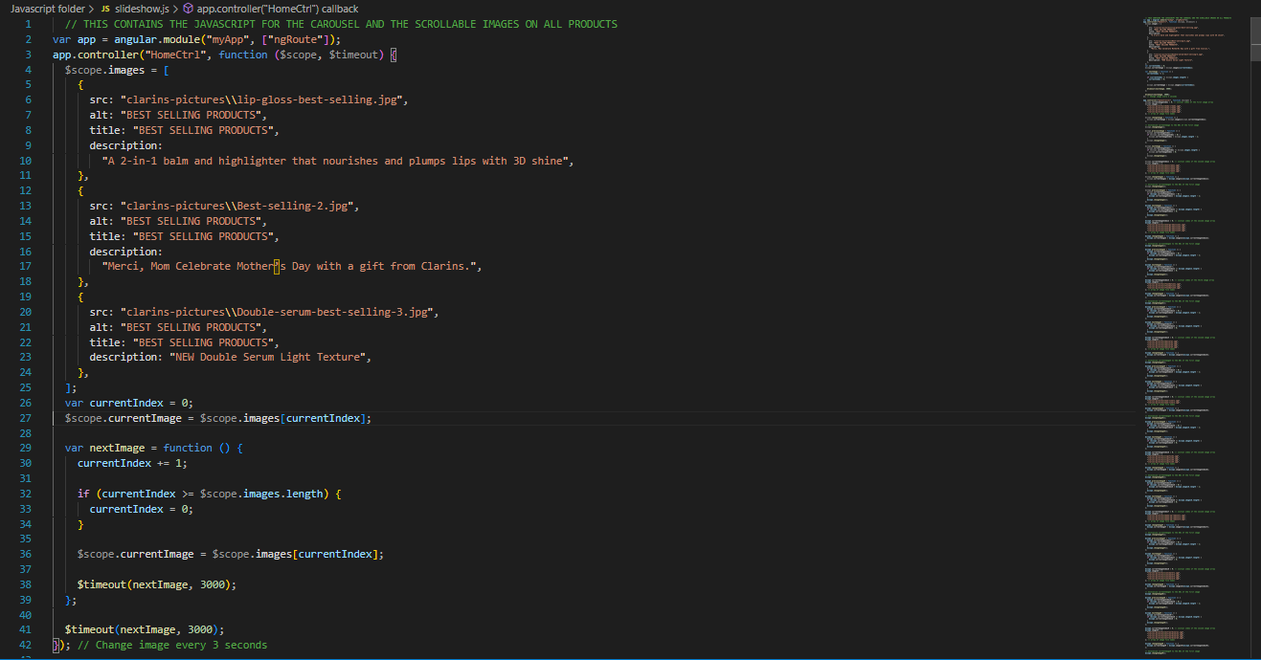

PRODUCTS PREVIEW

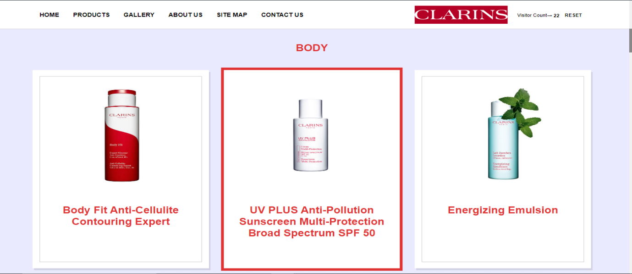

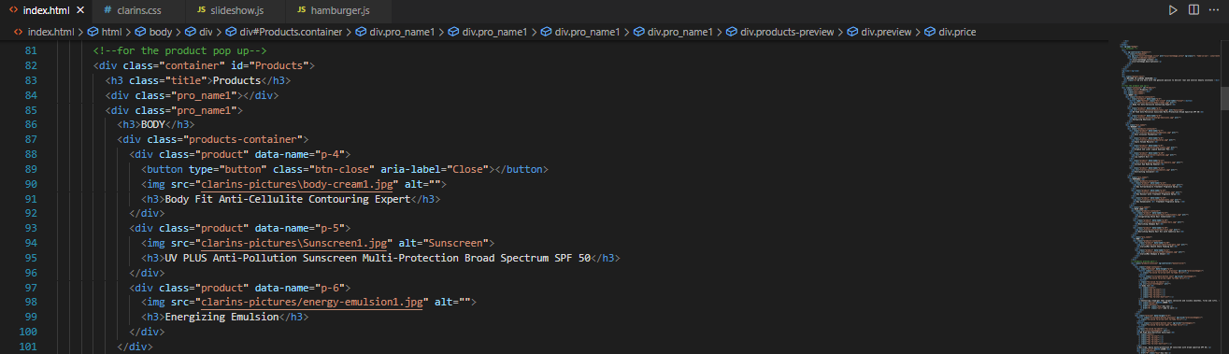

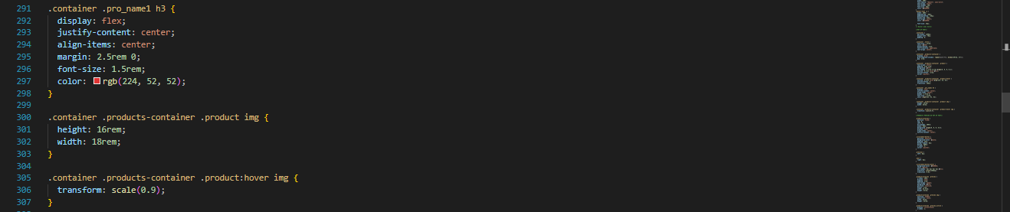

PRODUCTS POPUP/SCROLLABLE IMAGES

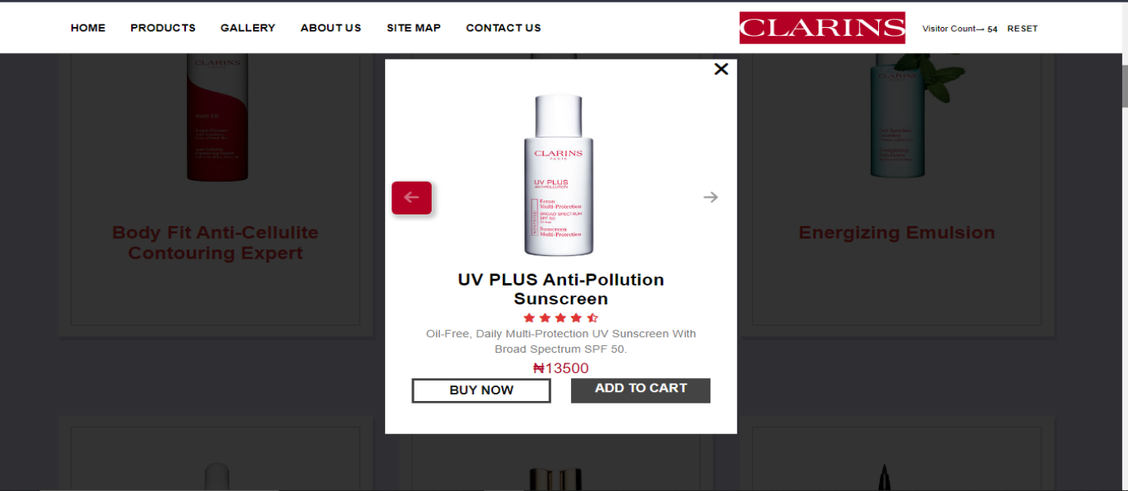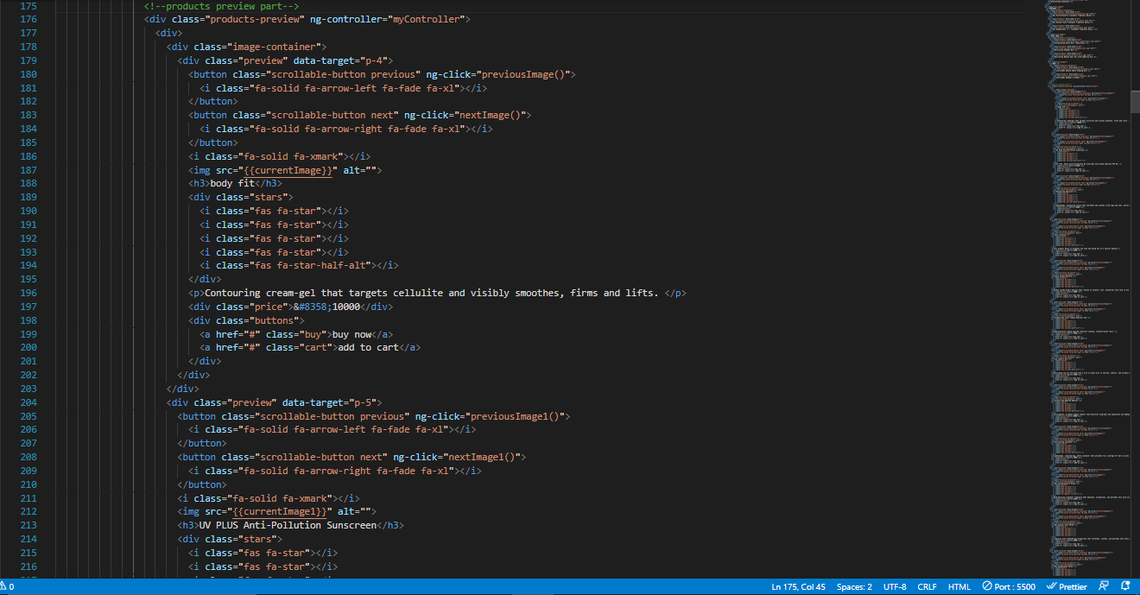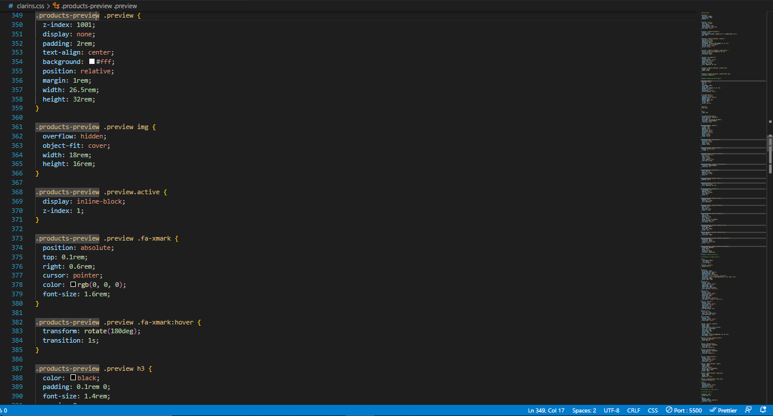

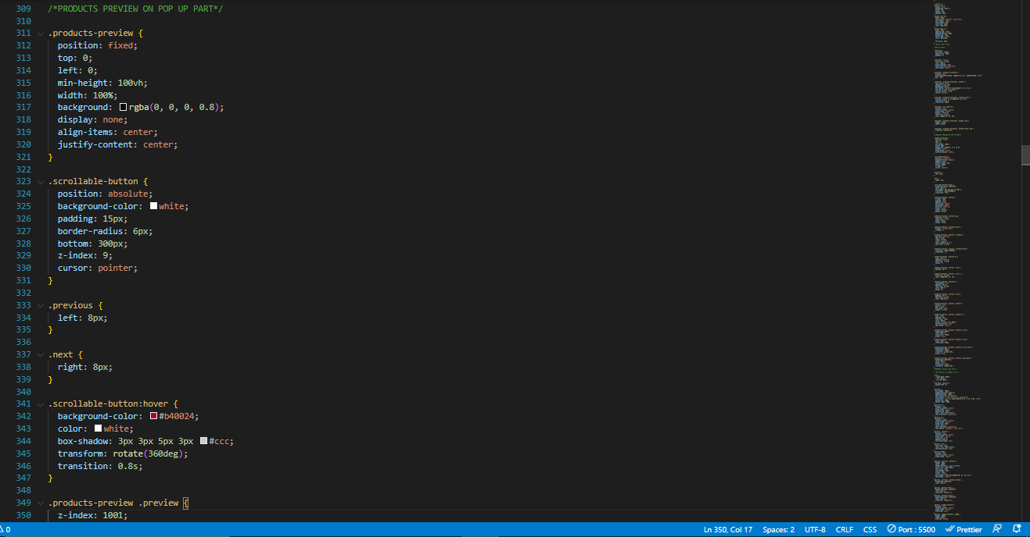

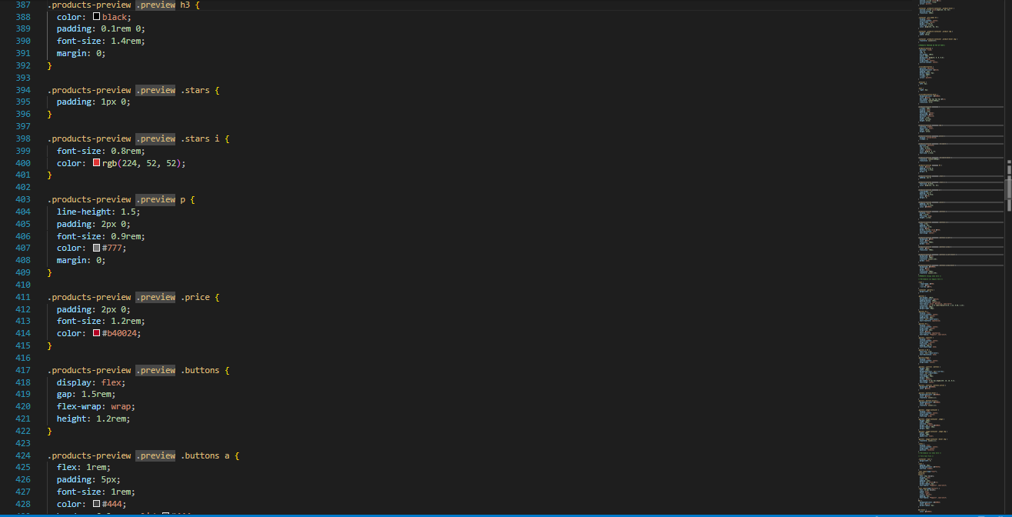

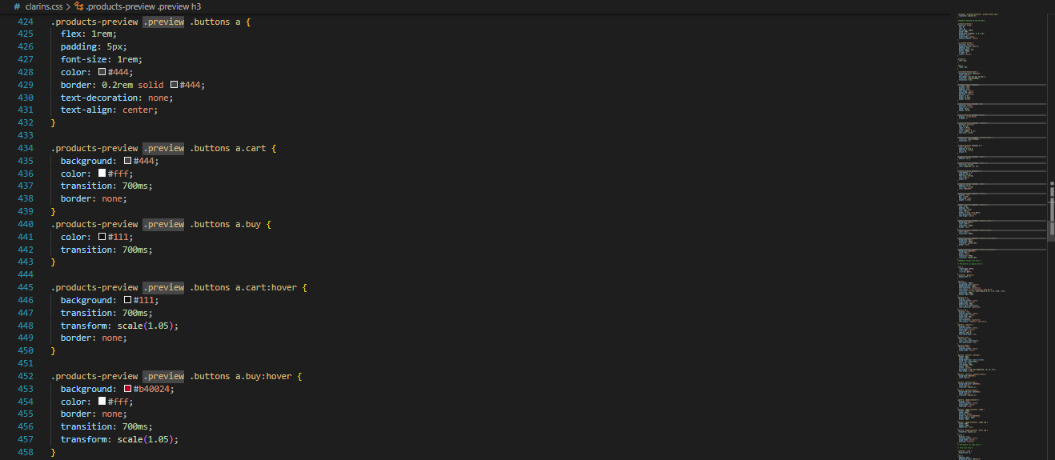

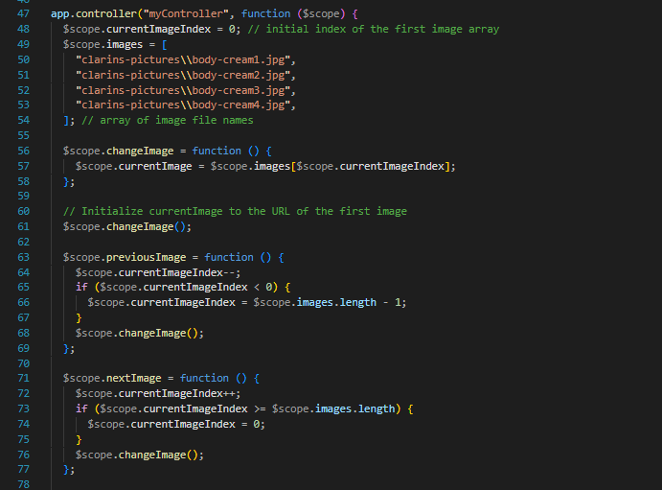

GALLERY/FILTERS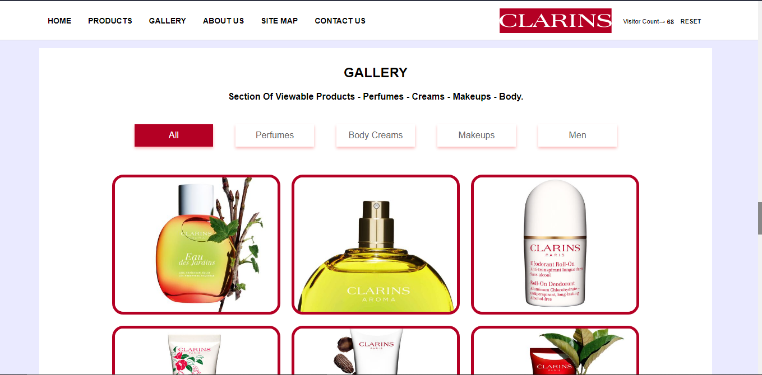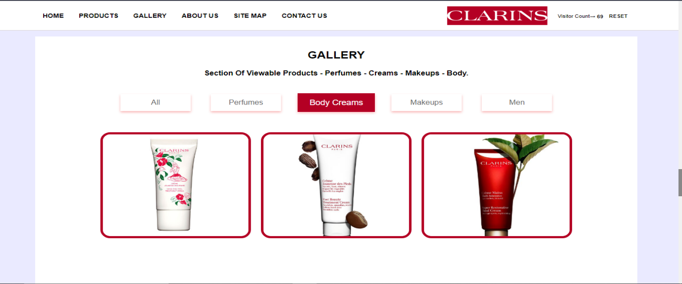

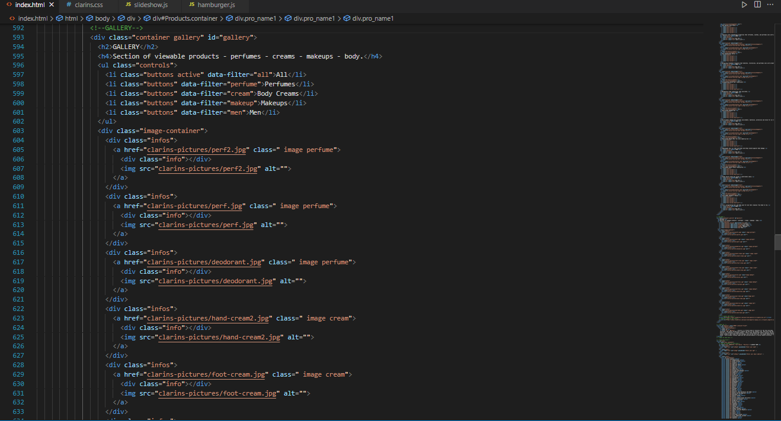

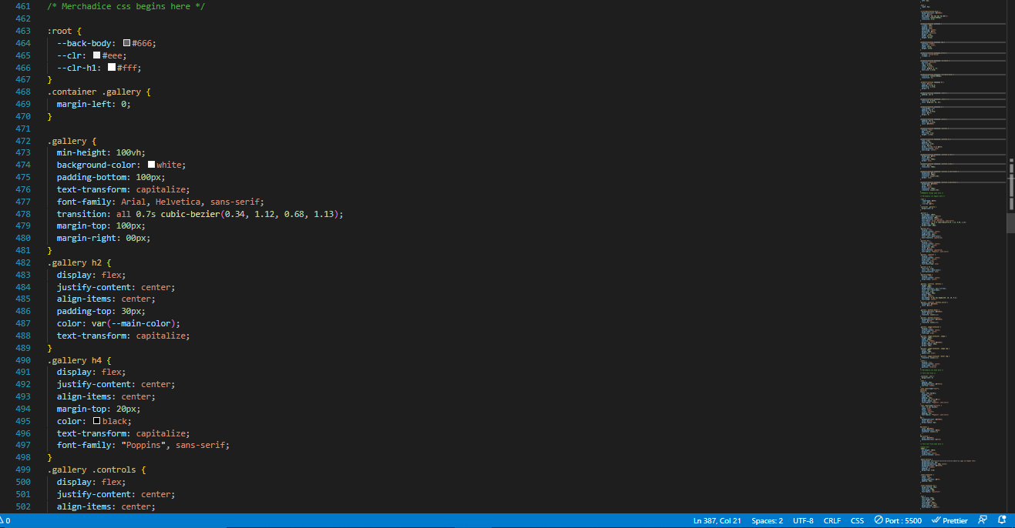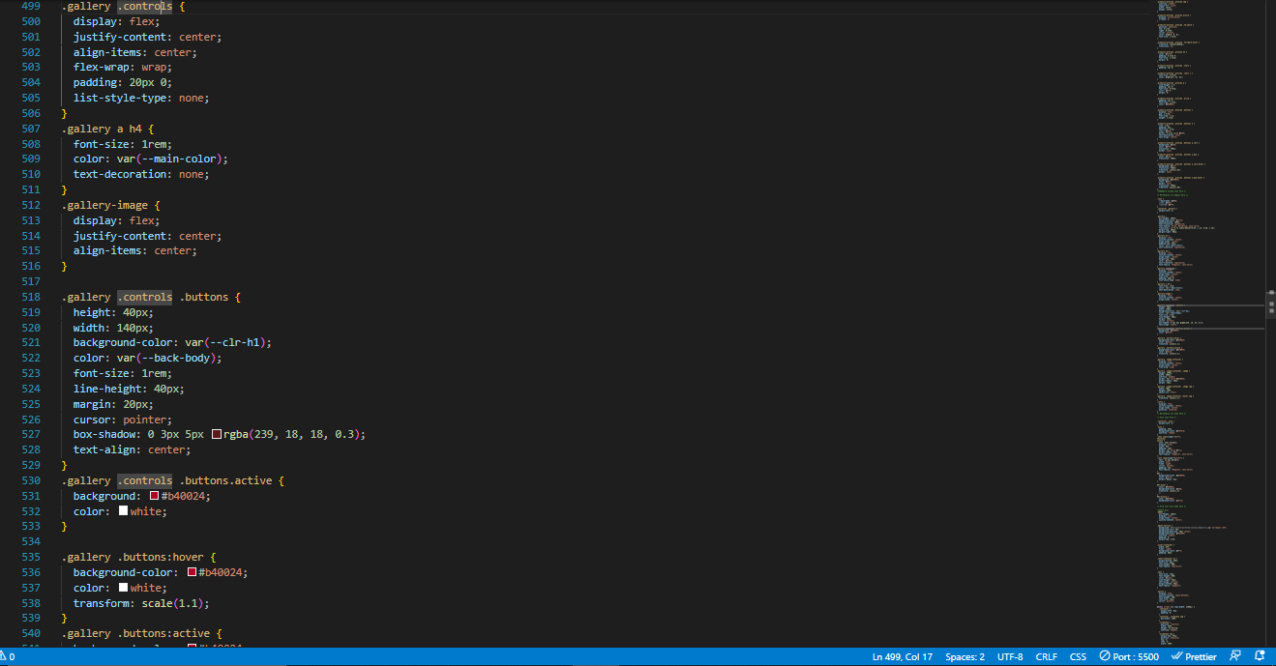

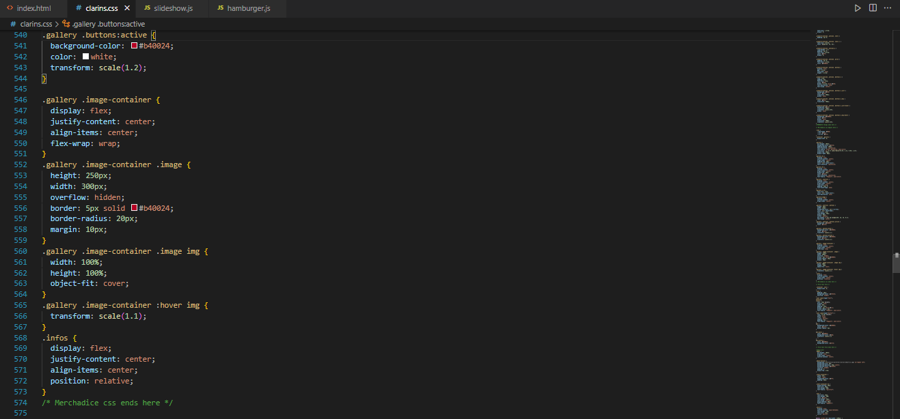

SITEMAP

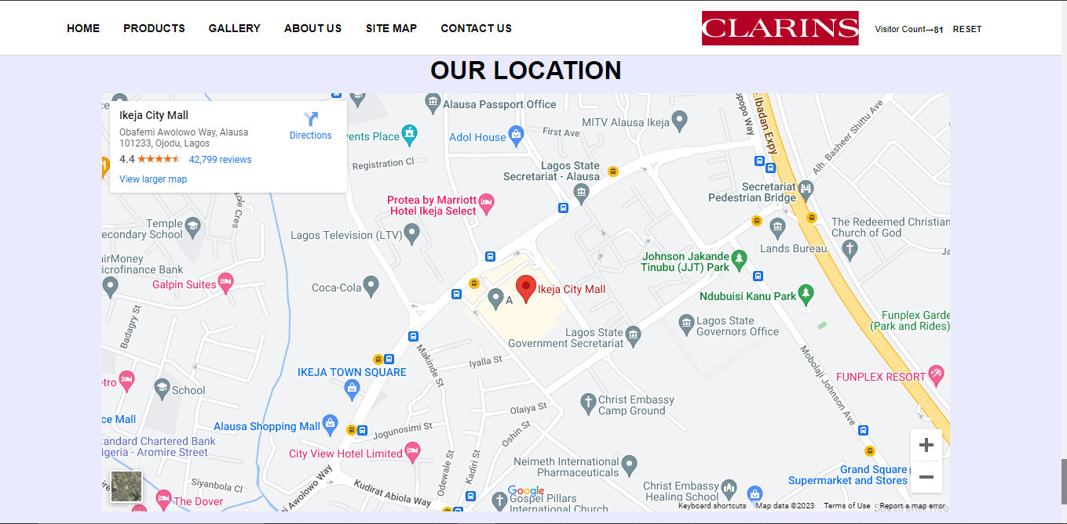

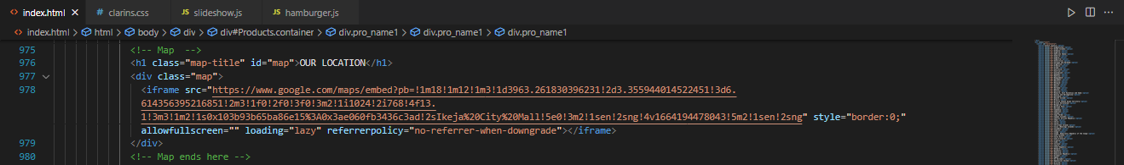

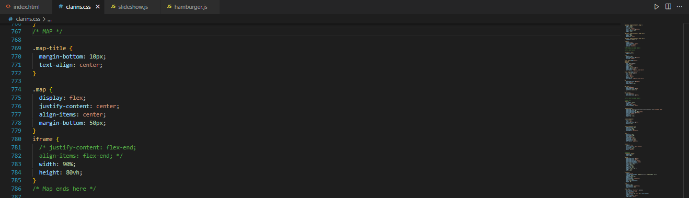

FOOTER

